# Install Visual Studio Code On CentOS 8 / RHEL 8

To install Visual Studio Code (vscode) on CentOS 8 / RHEL 8. Visual Studio Code is a popular source-code editor originally developed by Microsoft for Windows, but can now be installed on Linux and macOS. It is redefined and optimized for building and debugging modern web and cloud applications.

For RHEL/CentOS Linux distributions, the Visual Studio Code package is available on an RPM repository maintained by Microsoft.

## Step 1: Import Microsoft GPG key

Step 1 is to import the GPG key used for signing the packages.

sudo rpm --import https://packages.microsoft.com/keys/microsoft.asc

Once this is done, proceed to step 2.

## Step 2: Add VS Code repository

Once the GPG key is added, continue to add the VS Code repository.

sudo tee /etc/yum.repos.d/vscode.repo <<ADDREPO

[code]

name=Visual Studio Code

baseurl=https://packages.microsoft.com/yumrepos/vscode

enabled=1

gpgcheck=1

gpgkey=https://packages.microsoft.com/keys/microsoft.asc

ADDREPO

## Step 3: Install Visual Studio Code on CentOS 8 / RHEL 8

We’re now ready to install Visual Studio Code on CentOS 8 / RHEL 8. All you need to do is run the following command on your terminal.

sudo dnf install code

When prompted to Agree to installation, press “**y**“.

................

Updating Subscription Management repositories.

Visual Studio Code 924 B/s | 2.9 kB 00:03

Dependencies resolved.

================================================================================

Package Arch Version Repository Size

================================================================================

Installing:

code x86_64 code-1.59.0-1628120127.el8 code 66 M

Transaction Summary

================================================================================

Install 1 Package

Total download size: 66 M

Installed size: 189 M

Is this ok [y/N]: **y**

Downloading Packages:

See all the information regarding installed package.

$ **rpm -qi code**

Name : code

Version : 1.59.0

Release : 1628120127.el8

Architecture: x86_64

Install Date: Tue 10 Aug 2021 04:48:14 PM UTC

Group : Development/Tools

Size : 294006330

License : Multiple, see https://code.visualstudio.com/license

Signature : RSA/SHA256, Wed 04 Aug 2021 11:37:33 PM UTC, Key ID eb3e94adbe1229cf

Source RPM : code-1.59.0-1628120127.el8.src.rpm

Build Date : Wed 04 Aug 2021 11:35:54 PM UTC

Build Host : e7f9b0c250e3

Relocations : (not relocatable)

Packager : Visual Studio Code Team <vscode-linux@microsoft.com>

Vendor : Microsoft Corporation

URL : https://code.visualstudio.com/

Summary : Code editing. Redefined.

....

## Step 4: Launch Visual Studio Code on CentOS 8 / RHEL 8

After installing any package, you’ll definitely want to use it. To launch Visual Studio Code on CentOS 8 / RHEL 8, you can use CLI

$ code

or Gnome Activities search function.

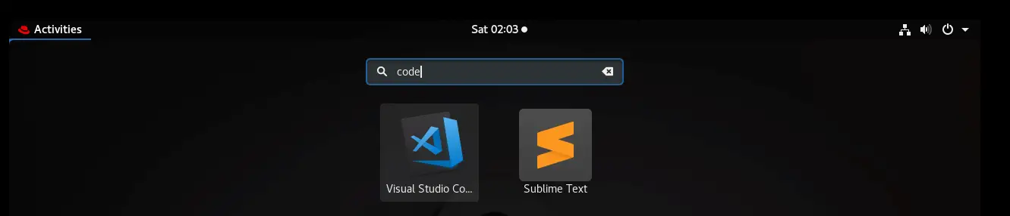

You should see the VS Code welcome window.

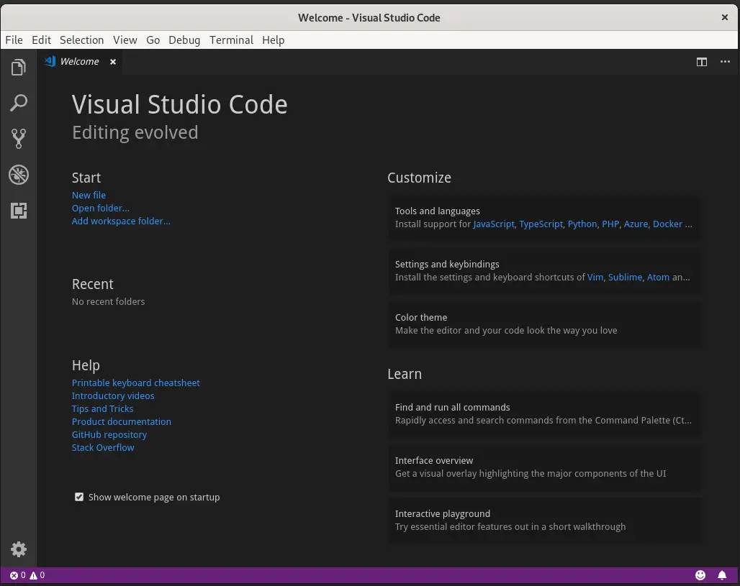

Enjoy your development with Visual Studio Code on Fedora. Check a comprehensive guide on how to[use VS Code](https://code.visualstudio.com/docs). Watching [Introductory Videos](https://code.visualstudio.com/docs/getstarted/introvideos) should also help you get started.